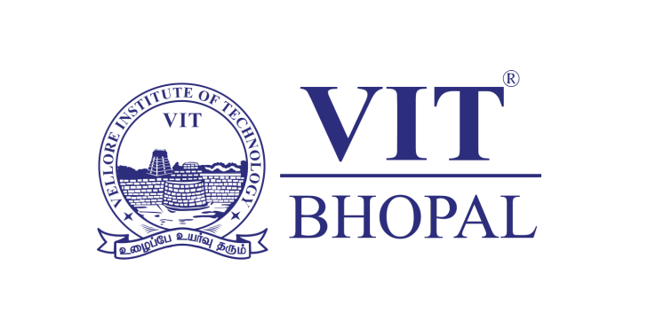

Digital Literacy Project Report

Name: Shreya Dhawan
Registration Number: 25BCY10238
Branch: Cybersecurity & Digital Forensics

Course Code: CSE0001
Course Title: Digital Literacy

Institution: VIT Bhopal University

Date: 31st March 2026

Introduction

In today’s digital era, digital literacy has become an essential skill for students to effectively learn, communicate, and grow professionally. This project was undertaken as part of the Digital Literacy course to develop a practical understanding of various digital tools, platforms, and online safety practices. As a Student Digital Ambassador, the objective was to build a comprehensive digital literacy portfolio that demonstrates awareness of responsible digital behaviour, professional communication, and the use of modern digital platforms.

The project is divided into five tasks, each focusing on a different aspect of digital literacy, including creating an infographic, building a digital portfolio, exploring coding and collaboration tools, understanding email etiquette, and learning about cybercrime awareness. Through these tasks, I gained valuable insights into how digital tools can be used effectively in both academic and professional environments.

Task 1

I created a digital literacy awareness infographic using Canva, as it is simple to use and offers a wide range of design templates and elements. The aim of my infographic was to present important digital literacy concepts in a way that is easy for students to understand at a glance.

In my design, I focused on three main areas: what digital literacy means, safe internet practices, and useful digital tools for students. I explained digital literacy as the ability to use digital platforms effectively and responsibly. I also included basic safety practices such as using strong passwords, avoiding suspicious links, and protecting personal information. Additionally, I highlighted commonly used tools like Google Docs, Google Drive, and GitHub, which are helpful for academic work.

While working on this task, I found it interesting to convert theoretical concepts into a visual format. The most challenging part for me was deciding how to keep the content concise while still making it informative and visually appealing. This task helped me understand the importance of presenting information clearly and creatively.
Task 2
In this task, I created my digital portfolio by setting up profiles on GitHub, LinkedIn, and Kaggle. These platforms are widely used by students and professionals to showcase their skills and connect with others.

GitHub is mainly used for sharing and managing coding projects, and I created a profile README to introduce myself and my learning goals. LinkedIn is a professional networking platform where I added my educational details to build a basic professional presence. Kaggle is a platform for data science and machine learning, and I created a simple profile to explore learning opportunities in this field.

Setting up these platforms helped me understand the importance of having a digital presence from the beginning of my academic journey. Over the next four years, I plan to regularly update my GitHub with projects, improve my LinkedIn profile with achievements, and use Kaggle to develop my technical skills. This task gave me a clear idea of how these platforms can support my academic and career growth.

Task 3

In this task, I explored both a coding practice platform and a collaboration tool. For the coding part, I used HackerRank and completed a beginner-level problem called “Solve Me First.” This helped me understand how coding platforms work and gave me a basic idea of logical problem-solving in programming.

For the collaboration part, I created a quiz using Google Forms based on digital literacy concepts. The form included five questions, such as multiple-choice and short answer questions. I also linked the form to a Google Sheet and recorded responses, which demonstrated how data can be collected and organized automatically.

This task helped me understand how coding platforms can improve problem-solving skills and how tools like Google Forms can be used for surveys and academic purposes. I believe these tools will be very useful in my academic journey and will help me manage tasks more efficiently.

Task 4

In today’s digital world, poor communication can easily lead to misunderstandings. For example, if a student sends an email to a professor without a proper subject line or greeting, the message may appear unprofessional and may even be ignored. This can create confusion and delay important communication.

To avoid such situations, it is important to follow proper email etiquette, including using a clear subject line, maintaining a polite tone, and structuring the email properly. In this task, I learned how to write professional emails and understood the importance of clarity and respect in online communication. This knowledge will help me communicate more effectively in both academic and professional environments.

Task 5

While researching cybercrime, I was surprised to learn how common UPI-based fraud has become, especially among students and new users of digital payment systems. I did not realize that something as simple as approving a request or sharing an OTP could lead to financial loss.

This task helped me understand how scammers use simple tricks to exploit a lack of awareness. One important habit I will change is being more cautious while handling online payments and verifying every transaction before approving it. I will also ensure that I never share sensitive information such as OTPs or PINs with anyone. This task increased my awareness about online safety and responsible digital behaviour.

Conclusion

Overall, this project helped me gain a strong understanding of digital literacy and its importance in today’s world. I learned how to use various digital tools, build a professional online presence, communicate effectively, and stay safe online. Each task provided practical experience that will be useful throughout my academic journey and future career.

This project also helped me develop confidence in using digital platforms responsibly and efficiently. I believe these skills will help me grow as a student and prepare me for real-world challenges in a digital environment.

References

- Canva (https://www.canva.com)
- GitHub (https://github.com)
- LinkedIn (https://www.linkedin.com)
- Kaggle (https://www.kaggle.com)
- HackerRank (https://www.hackerrank.com)
- Google Forms (https://forms.google.com)
- National Cyber Crime Portal (https://cybercrime.gov.in)

